|  |
| --- |
| [Cannot open include file: 'stdio.h' - Visual Studio Community 2017 - C++ Error](https://stackoverflow.com/questions/44219901/cannot-open-include-file-stdio-h-visual-studio-community-2017-c-error) |
| |  |  | | --- | --- | | 13down vote | Got same problem with project porting from VS2013 to VS2017, Fix: change "Properties->General->Windows SDK Version" to 10 | |  |  | |  |  | |

Select 🡺 vs chang>updata|launch| More>

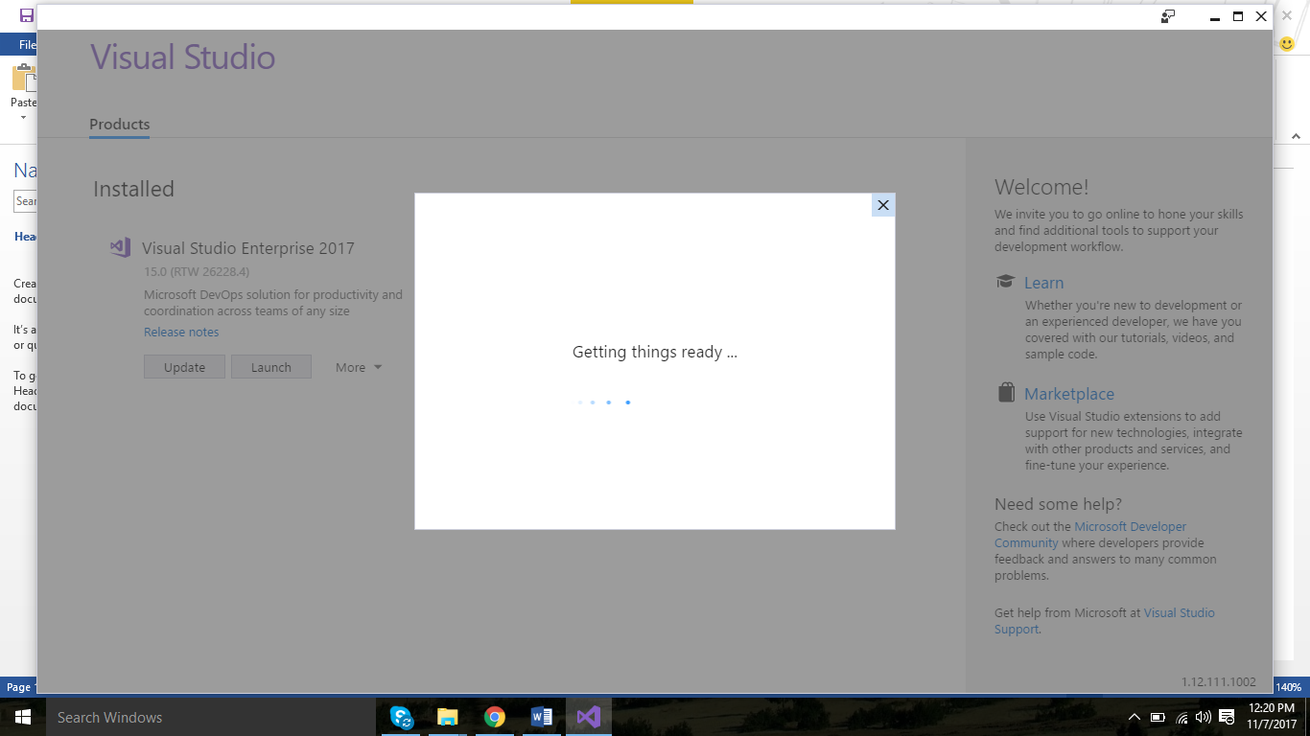

Install this 🡺

Microsoft.VisualStudio.Component.VC.Tools.x86.x64

